DFT Analysis of the Raman Spectrum of a Glycerol–Phosphate Fragment Modeling the Lipoteichoic Acid Backbone

1. Introduction
Lipoteichoic acid (LTA) is a major structural component of the cell wall of Gram-positive bacteria. It is anchored to the cytoplasmic membrane through a glycolipid and extends outward as a polymer of repeating glycerol–phosphate units.
LTA contributes to bacterial adhesion, cell wall maintenance, and activation of the host immune system, and it is implicated in inflammatory responses. LTA interacts with host immune receptors such as Toll-like receptor 2 (TLR2), triggering signaling pathways that lead to the production of inflammatory cytokines.
Because of its biological significance, LTA has been studied using a range of analytical techniques, including Raman spectroscopy.
Raman spectroscopy is a vibrational technique that provides molecular fingerprints based on characteristic vibrational modes. It is increasingly used as a label-free method for identifying bacterial components and detecting pathogens. However, interpretation of experimental Raman spectra is often challenging because of overlapping bands and complex vibrational couplings.
Computational methods such as Density Functional Theory (DFT) can simulate vibrational frequencies and Raman activities, helping to assign experimental bands to specific molecular vibrations.
In this work, a representative glycerol–phosphate fragment modeling the LTA backbone was studied using DFT calculations to obtain a theoretical Raman spectrum and analyze the vibrational modes associated with characteristic phosphate and glycerol bands.

2. Structure of Lipoteichoic Acid
Lipoteichoic acid is composed of three main structural components:
• A glycolipid membrane anchor
• A poly(glycerol–phosphate) backbone
• Substituent groups such as D-alanine residues or sugars
The general structure of LTA can be represented as:
Lipid anchor – (Gro–P)ₙ
where:
Gro = glycerol
P = phosphate
The backbone consists of alternating glycerol and phosphate groups:
glycerol – phosphate – glycerol – phosphate
Typical LTA molecules contain approximately 10–20 repeating glycerol–phosphate units, forming large polymers with hundreds of atoms.
Because of this molecular size, quantum chemical simulations on the full polymer are computationally expensive. Therefore, computational studies often employ smaller molecular fragments that preserve the essential structural features responsible for the main spectroscopic signatures.
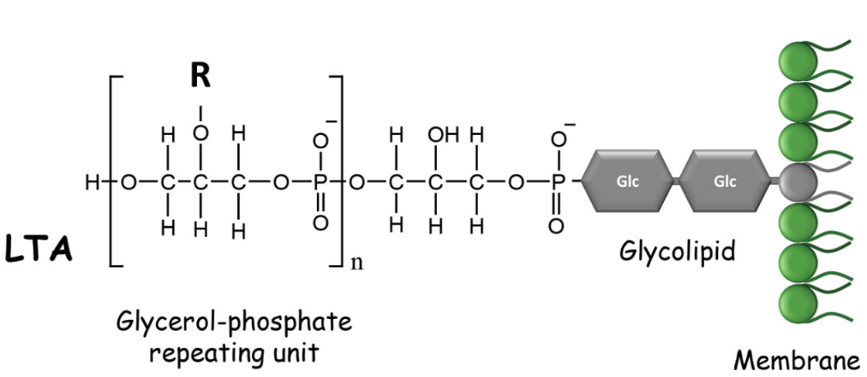
Figure 1. Schematic representation of lipoteichoic acid (LTA) showing the repeating glycerol–phosphate backbone and the glycolipid membrane anchor. Only the glycerol–phosphate region is modeled in the present work.

3. Selection of Molecular Fragment
To make the quantum-chemical simulations computationally feasible, a representative fragment of the LTA backbone was used instead of the full polymer.
The selected fragment contains two glycerol–phosphate repeating units, which approximately preserves the local chemical environment responsible for Raman-active backbone vibrations.
The fragment can be written as:
HO–CH₂–CH(OH)–CH₂–O–PO₃–O–CH₂–CH(OH)–CH₂–OH
This model includes the key functional groups relevant for Raman activity:
Functional Group | Role in Raman Spectrum
Phosphate (PO₄) | Strong Raman-active vibrations
C–O–P linkage | Characteristic backbone vibrations
Hydroxyl groups | Hydrogen bonding interactions
Glycerol backbone | Carbon–oxygen vibrational modes
Although smaller than the full polymer and lacking the lipid anchor and substituents, this fragment retains the main chemical features responsible for the backbone vibrational signature of LTA.

4. Molecular Structure Construction
The molecular structure of the glycerol–phosphate fragment was built using Avogadro, an open-source molecular editor for visualization and modeling.
Instead of constructing the molecule atom by atom, the structure was generated from a SMILES representation.
SMILES used
OP(=O)(O)OCC(O)COP(=O)(O)OCC(O)CO
This SMILES string describes a glycerol–phosphate fragment with two phosphate groups connected through glycerol units.
Steps used
- Open Avogadro
- Navigate to Build → Insert → SMILES
- Paste the SMILES string
- Click Insert
Avogadro automatically converts the SMILES notation into an initial three-dimensional molecular structure.
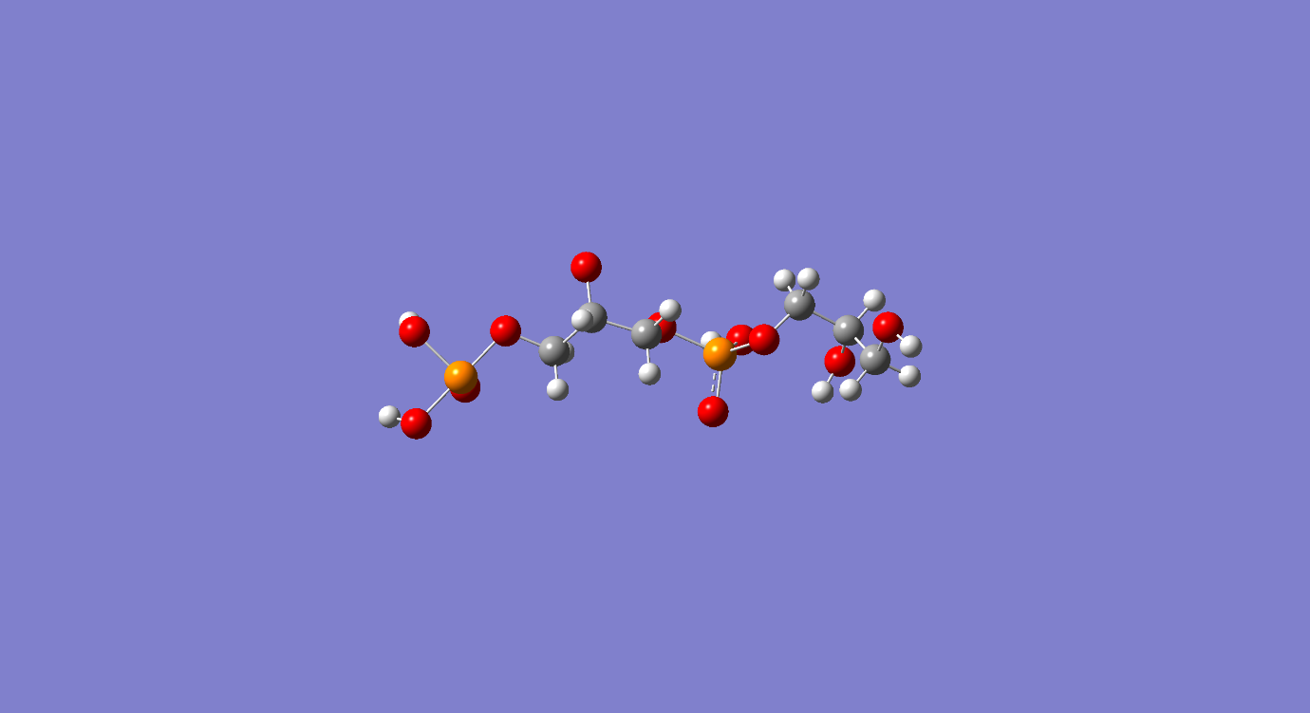
Figure 2. Three-dimensional structure of the glycerol–phosphate fragment generated in Avogadro. This structure was used as the starting geometry for subsequent optimization and DFT calculations.

5. Geometry Optimization
After constructing the molecular structure, an initial geometry optimization was performed to obtain a reasonable starting conformation.
Initial optimization was carried out using the Universal Force Field (UFF) implemented in Avogadro.
This step reduces unrealistic bond angles, minimizes steric clashes, and provides a suitable starting geometry for subsequent quantum-mechanical calculations.
The optimized structure was exported as Cartesian coordinates and used as input for the DFT calculations in Gaussian 16.

6. Quantum Chemical Simulation
Quantum-chemical calculations were performed with Gaussian 16.
The calculations included:
• Geometry optimization
• Harmonic vibrational frequency analysis
• Raman activity calculations
Density Functional Theory (DFT) with the B3LYP hybrid functional was employed, as this level of theory is widely used for simulating vibrational spectra.
The 6-31G(d) basis set was used, providing a compromise between computational cost and accuracy for organic and phosphate-containing systems.
All vibrational frequencies were calculated within the harmonic approximation. DFT methods typically overestimate vibrational frequencies, and scaling factors (typically ~0.96 for B3LYP/6-31G(d)) are often applied when comparing theoretical predictions with experimental data.

7. Simulation Parameters
The Gaussian calculation used the following keywords:
# B3LYP/6-31G(d) Opt Freq Raman SCF=Tight Int=UltraFine SCRF=(SMD,Solvent=Water)
Explanation of parameters:
Parameter | Purpose
B3LYP | Hybrid DFT functional
6-31G(d) | Basis set with polarization functions
Opt | Geometry optimization
Freq | Vibrational frequency calculation
Raman | Raman activity calculation
SCF=Tight | Strict electronic convergence
Int=UltraFine | High-accuracy integration grid
SCRF=SMD | Implicit solvent model (water)
The SMD implicit solvent model was used to approximate the aqueous environment in which LTA normally resides.

8. Convergence of Calculation
The Gaussian calculation successfully converged and the output file ended with the message:
Normal termination of Gaussian 16
This indicates that:
• The self-consistent field (SCF) procedure converged
• Geometry optimization reached a stationary point
• Vibrational frequency and Raman activity calculations completed successfully
No imaginary frequencies were obtained, confirming that the optimized structure corresponds to a local minimum on the potential energy surface.
The final electronic energy was:
E = −1748.81207109 Hartree

9. Raman Spectroscopy Results
The vibrational frequency calculation produced Raman-active modes corresponding to molecular vibrations of the glycerol–phosphate backbone fragment.
Several characteristic Raman bands were obtained, which can be assigned to vibrations of the phosphate units and the glycerol backbone.
Raman Shift (cm⁻¹) | Assignment
481 | O–P–O bending
922 | P–O–C stretching
1291 | O–H deformation
3046–3091 | C–H stretching
3712 | O–H stretching
The band near 481 cm⁻¹ is assigned to O–P–O bending motions within phosphate groups.
The 922 cm⁻¹ band arises mainly from P–O–C stretching of phosphate ester linkages.
The band at 1291 cm⁻¹ corresponds to deformation of hydroxyl groups in the glycerol backbone.
In the high-frequency region, the bands at 3046–3091 cm⁻¹ correspond to C–H stretching vibrations of the glycerol units, while the band near 3712 cm⁻¹ is attributed to O–H stretching of weakly hydrogen-bonded or free hydroxyl groups.
Most characteristic vibrational information appears in the fingerprint region (500–1500 cm⁻¹), where phosphate and glycerol backbone vibrations dominate the spectrum.
The simulated spectrum is dominated by strong phosphate-related modes in the low- to mid-frequency region and by C–H and O–H stretching bands at higher wavenumbers.
These features are consistent with expected group frequencies for phosphate esters and polyalcohol backbones reported in the literature.
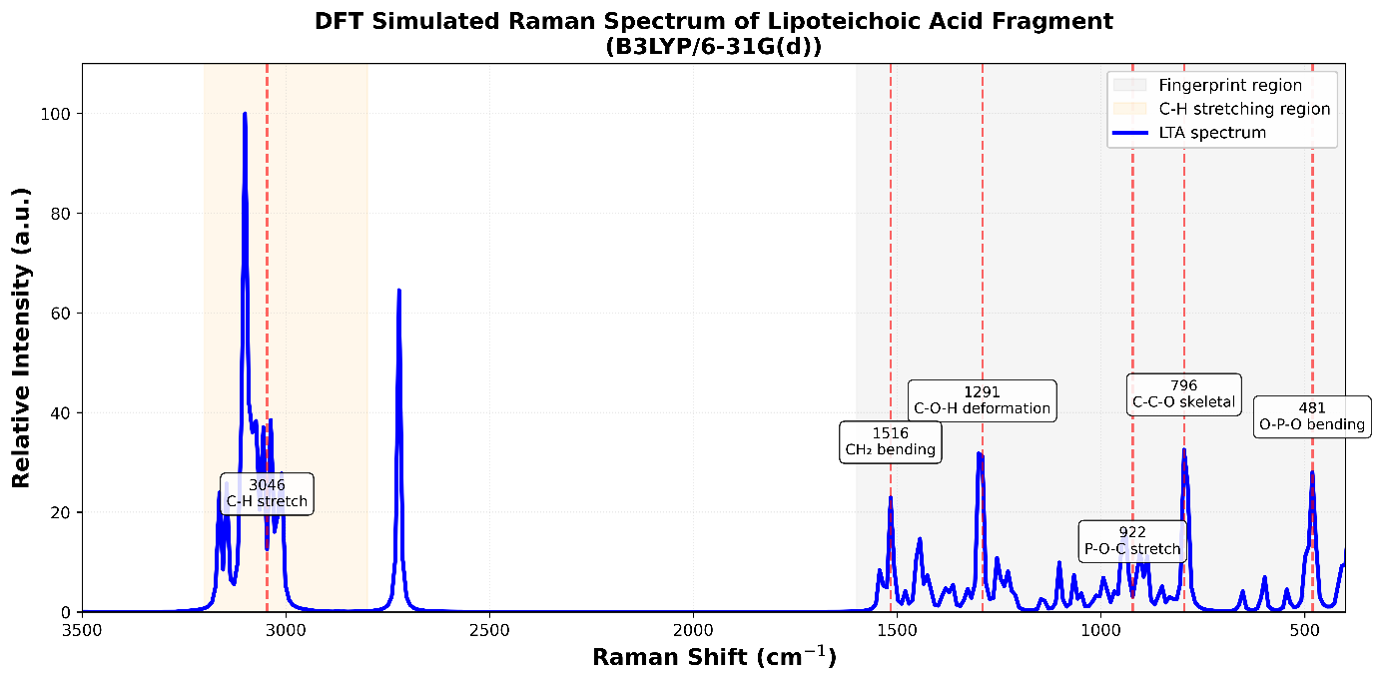
Figure 3. Simulated Raman spectrum of the glycerol–phosphate fragment obtained from DFT calculations at the B3LYP/6-31G(d) level.

10. Limitations
The present model represents only a small fragment of the full lipoteichoic acid polymer and does not include lipid anchors or substituent groups.
Therefore, the calculated spectrum primarily captures backbone vibrational features rather than the full complexity of native LTA.

11. References
Neuhaus, F. C., & Baddiley, J. (2003).
A continuum of anionic charge: structures and functions of D-alanyl-teichoic acids in Gram-positive bacteria.
Microbiology and Molecular Biology Reviews, 67(4), 686–723.
Percival, M. D., & Chalmers, I. M. (1970).
The chemistry of lipoteichoic acids.
Biochemical Journal, 117, 29–35.
Socrates, G. (2001).
Infrared and Raman Characteristic Group Frequencies: Tables and Charts.
John Wiley & Sons.

